**MODULE 3 & 4 ASSIGNMENT Q-A**

* What is RDBMS ?

RDBMS stands for Relational Database Management System. RDBMS is the basis for SQL, and for all modern database systems like MS SQL Server, IBM DB2, Oracle, MySQL, and Microsoft Access. A Relational database management system (RDBMS) is a database management system (DBMS) that is based on the relational model as introduced by E. F. Codd.

* What is SQL ?

SQL is Structured Query Language, which is a computer language for storing, manipulating and retrieving data stored in relational database. SQL is the standard language for Relation Database System. All relational database management systems like MySQL, MS Access, Oracle, Sybase, Informix, postgres and SQL Server use SQL as standard database language.

* How Many constraint and describes it self ?

1.Primary key –It will avoid data duplication.

2.Foreign key – It will pass the reference and we will use for it joins.

3.Unique key – Uniqually identified the data.

* Write SQL Commands

SQL Commands **DDL** – Data Definition Language **DML** – Data Manipulation Language **DCL** – Data Control Language **DQL** – Data Query Language

**(1)DDL** - Data Definition Language Command Description CREATE Creates a new table, a view of a table, or other object in database ALTER Modifies an existing database object, such as a table. DROP Deletes an entire table, a view of a table or other object in the database.

**(2)DML** – Data Manipulation Language Command Description INSERT Creates a record UPDATE Modifies records DELETE Deletes records.

**(3)DCL** – Data Control Language Command Description GRANT Gives a privilege to user REVOKE Takes back privileges granted from user 1. Rollback 2. Commit are 2 commands of DCL.

**(4)DQL -** Data Query Language Command Description SELECT Retrieves certain records from one or more tables.

Select all:

SELECT * FROM info

Select Row:

SELECT * FROM info where id=?

Select Col:

SELECT colname FROM info

order by:

SELECT * FROM info ORDER by name DESC

* What is join?

A JOIN clause is used to combine rows from two or more tables, based on a related column between them.

* Write type of joins.

JOINS:

1. INNER JOIN 2) LEFT JOIN:
2. RIGHT JOIN 4) FULL JOIN:

* Difference between RDBMS vs DBMS

**RDBMS**

1. RDBMS stands for Relational Database Management System.
2. A Relational database management system (RDBMS) is a database management system (DBMS) that is based on the relational model as introduced by E. F. Codd.
3. Tables are related (joined) based on common fields.

**DBMS**

1. DBMS stands for Database Management System.
2. A DBMS consists of 2 main pieces: the data the DB engine.
3. the data is typically stored in one or more files Two most common types of DBMS are: Local Server

* What is API Testing ?

Application Programming Interface (API) is a software interface that allows two applications to interact with each other without any user intervention

another definition , API (Application Programming Interface) is a computing interface which enables communication and data exchange between two separate software systems.

* Types of API Testing ?

There are mainly 3 types of API Testing **Open** **APIs**: These types of APIs are publicly available to use like OAuth APIs from Google. It has also not given any restriction to use them. So, they are also known as Public APIs. **Partner** **APIs**: Specific rights or licenses to access this type of API because they are not available to the public. **Internal** **APIs**: Internal or private. These APIs are developed by companies to use in their internal systems. It helps you to enhance the productivity of your teams.

* What is Responsive Testing?

A responsive web design involves creating a flexible web page that is accessible from any device, starting from a mobile phone to a tablet.

* Which types of tools are available for Responsive Testing ?

Responsive Testing Tools - 1.LT Browser 2.Lembda Testing 3.Google Resizer 4.I am responsive 5.Pixel tuner

* What is the full form of .IPA , .APK ?

IPA stands for "iOS App Store Package" and APK stands for “Android Application Package”

* How to create step for to open the developer option mode ON ?

1)Open settings on mobile

2)Click on System management

3)Click on About Phone

4)Click on software version

5)Click on developer options mode and then turn it “ON”

6)Click on USB debugging and then allow it.

* What is Error, Defect, Bug and failure ?

Errors, Defects, Bug and Failures “A mistake in coding is called error, error found by tester is called defect, defect accepted by development team then it is called bug, build does not meet the requirements then it is failure” **Error**: A discrepancy between a computed, observed, or measured value or condition and the true, specified, or theoretically correct value or condition. This can be a misunderstanding of the internal state of the software, an oversight in terms of memory management, confusion about the proper way to calculate a value, etc. 120 Errors, Defects and Failures **Failure**: The inability of a system or component to perform its required functions within specified performance requirements. See: bug, crash, exception, and fault. **Bug**: A fault in a program which causes the program to perform in an unintended or unanticipated manner. See: anomaly, defect, error, exception, and fault. Bug is terminology of Tester. **Defect**: Commonly refers to several troubles with the software products, with its external behavior or with its internal features.

* **What is Bug Life Cycle ?**

Bug(Defect) Life Cycle “A computer bug is an error, flaw, mistake, failure, or fault in a computer program that prevents it from working correctly or produces an incorrect result. Bugs arise from mistakes and errors, made by people, in either a program’s source code or its design.” The duration or time span between the first time defects is found and the time that it is closed successfully, rejected, postponed or deferred is called as ‘Defect Life Cycle’. When a bug is discovered, it goes through several states and eventually reaches one of the terminal states, where it becomes inactive and closed. The process by which the defect moves through the life cycle is depicted next slide.

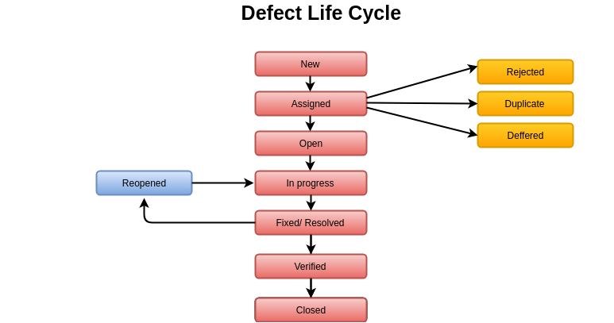

As you can see from above diagram, a defect‘s state can be divided into Open or Closed. When a bug reaches one of the Closed or Terminal states, its lifecycle ends. Each state has one or more valid states to move to. This is to ensure that all necessary steps are taken to resolve or investigate that defect. For example, a bug should not move from Submitted state to resolved state without having it open. In a typical scenario, as soon as a bug is identified, it is logged into the bug tracking system with status as Submitted. After ascertaining the validity of the defect, it is given the “Open” Status.

* What is priority ?

Priority is Relative and Business-Focused. Priority defines the order in which we should resolve a defect. Should we fix it now, or can it wait? This priority status is set by the tester to the developer mentioning the time frame to fix the defect. If high priority is mentioned then the developer has to fix it at the earliest. The priority status is set based on the customer requirements. For example: If the company name is misspelled in the home page of the website, then the priority is high and severity is low to fix it.

* What is severity ?

Severity is absolute and Customer-Focused. It is the extent to which the defect can affect the software. In other words it defines the impact that a given defect has on the system. For example: If an application or web page crashes when a remote link is clicked, in this case clicking the remote link by an user is rare but the impact of application crashing is severe. So the severity is high but priority is low.

* Difference between priority and severity

**Priority**

1. Priority is Relative and Business-Focused.
2. Priority defines the order in which we should resolve a defect. Should we fix it now, or can it wait?
3. The priority status is set based on the customer requirements.

**Severity**

1. Severity is absolute and Customer-Focused.
2. It is the extent to which the defect can affect the software. In other words it defines the impact that a given defect has on the system.
3. Severity can be of following types:

🡪 Critical

🡪 Major (High)

🡪 Moderate (Medium)

🡪 Minor (Low)

🡪Cosmetic

* Bug categories are…

**There are 5 categories are below:**

1. Data Quality/Database Defects
2. Critical Functionality Defects
3. Functionality Defects
4. Security Defects
5. User Interface Defects

* Advantage of Bugzilla

🡪Bugzilla is an open-source issue/bug tracking system that allows developers effectively to keep track of outstanding problems with their product. It is written in Perl and uses MYSQL database. 🡪Bugzilla is a defect tracking tool, however it can be used as a test management tool as such it can be easily linked with other test case management tools like Quality Center, Test link etc. 🡪This open bug-tracker enables users to stay connected with their clients or employees, to communicate about problems effectively throughout the datamanagement chain.

🡪 Key features of Bugzilla includes 1.Advanced search capabilities 2.E-mail Notifications 3.Modify/file Bugs by e-mail 4.Time tracking 5.Strong security 6.Customization 7.Localization.

END